Supplementary Materials
Supplementary Table 1. Information on missing data.
Variables | Missing information
Preoperative albumin | 14 (2.1%)
Hemoglobin | 5 (0.6%)
Left ventricular ejection fraction | 48 (7.4%)
Total output | 15 (2.3%)
Total input | 1 (0.2%)
The length of aortic cross-clamping | 63 (9.7%)

Supplementary Table 2. Patient demographics and baseline characteristics stratified by the TyG-BMI quartiles
Characteristic | Q1 [106,165] | Q2 [166,194] | Q3 [195,219] | Q4 [220,403] | Statistic | P-value
TyG-BMI | 155 [146, 160] | 181 [174, 187] | 206 [200, 212] | 239 [230, 251] | 610.31 | <0.001
CSA-AKI | 26 (16.0) | 34 (20.9) | 75 (46.0) | 89 (54.6) | 77.09 | <0.001
Age (years) | 55 [45, 65] | 58 [53, 66] | 60 [51, 65] | 59 [53, 65] | 10.81 | 0.013
Sex (woman) | 96 (58.9) | 81 (49.7) | 81 (49.7) | 82 (50.3) | 3.98 | 0.263
BMI (kg/m²) | 18.9 [17.8, 19.6] | 21.5 [20.5, 22.4] | 23.5 [22.7, 24.4] | 26.4 [25.1, 27.9] | 533.99 | <0.001
Preoperative medical histories
Hypertension | 22 (13.5) | 33 (20.2) | 49 (30.1) | 77 (47.2) | 52.40 | <0.001
Diabetes | 4 (2.5) | 15 (9.2) | 30 (18.4) | 47 (28.8) | 51.11 | <0.001
Coronary heart disease | 60 (36.8) | 89 (54.6) | 84 (51.5) | 107 (65.6) | 27.68 | <0.001
Hyperuricemia | 46 (28.2) | 63 (38.7) | 60 (36.8) | 66 (40.5) | 6.25 | 0.100
Preoperative Lab results
Albumin (g/L) | 39.3 [36.1, 42.2] | 38.7 [36.0, 41.6] | 39.0 [36.8, 41.8] | 39.4 [37.5, 41.8] | 4.02 | 0.259
LDL-C (mg/dL) | 86 [69, 107] | 98 [80, 118] | 96 [77, 122] | 99 [77, 122] | 18.20 | <0.001
HDL-C (mg/dL) | 51 [42, 62] | 45 [38, 56] | 44 [39, 51] | 43 [37, 50] | 28.64 | <0.001
eGFR (mL/min/1.73m²) | 87 [70, 105] | 84 [68, 100] | 83 [70, 98] | 82 [65, 98] | 7.98 | 0.046
BUN (mmol/L) | 5.92 [4.49, 7.78] | 5.92 [4.70, 7.89] | 5.92 [4.62, 7.54] | 5.64 [4.51, 7.84] | 0.15 | 0.985
TyG index | 8.10 [7.79, 8.39] | 8.40 [8.17, 8.73] | 8.70 [8.42, 9.08] | 9.14 [8.72, 9.58] | 240.82 | <0.001
TG (mg/dL) | 74 [59, 96] | 94 [74, 126] | 119 [94, 158] | 163 [112, 229] | 212.10 | <0.001
Glucose (mg/dl) | 84 [77, 96] | 91 [80, 111] | 95 [83, 116] | 103 [88, 148] | 67.25 | <0.001
Hemoglobin (g/L) | 131 [118, 144] | 134 [121, 148] | 137 [125, 149] | 138 [126, 150] | 9.96 | 0.019
Preoperative LVEF (%) | 63 [57, 68] | 65 [60, 69] | 63 [58, 67] | 63 [57, 67] | 5.80 | 0.122
Coronary Angiography | 114 (69.9) | 129 (79.1) | 130 (79.8) | 130 (79.8) | 6.43 | 0.093
Preoperative medications
Cardiovascular medications | 103 (63.2) | 106 (65.0) | 113 (69.3) | 132 (81.0) | 14.77 | 0.002
Lipid-lowering medications | 43 (26.4) | 63 (38.7) | 69 (42.3) | 90 (55.2) | 28.55 | <0.001
Anti-diabetic medications | 8 (4.9) | 12 (7.4) | 22 (13.5) | 35 (21.5) | 25.61 | <0.001
Diuretic medications | 148 (90.8) | 158 (96.9) | 159 (97.5) | 146 (89.6) | 14.03 | 0.003
Surgical information
ASA classifications |  |  |  |  | 1.60 | 0.660
II-III | 47 (28.8) | 57 (35.0) | 51 (31.3) | 49 (30.1)
IV-V | 116 (71.2) | 106 (65.0) | 112 (68.7) | 114 (69.9)
TW-AUC MBP < 60 mmHg | 1.90 [1.12, 3.14] | 1.52 [0.78, 2.97] | 1.76 [0.85, 2.77] | 1.85 [0.99, 3.26] | 5.11 | 0.164
Total output (ml) | 1200 [1000, 1700] | 1300 [1000, 1700] | 1200 [950, 1600] | 1250 [1000, 1800] | 6.97 | 0.073
Total input (ml) | 1000 [750, 1000] | 1000 [1000, 1250] | 1000[1,000, 1250] | 1000 [750, 1000] | 5.71 | 0.127
RBC transfusion | 29 (17.8) | 18 (11.0) | 19 (11.7) | 14 (8.6) | 6.95 | 0.073
Plasma transfusion | 73 (44.8) | 86 (52.8) | 72 (44.2) | 80 (49.1) | 3.17 | 0.367
The length of anesthesia (min) | 335 [285, 405] | 365 [310, 420] | 355 [305, 415] | 365 [310, 435] | 12.60 | 0.006
The length of ACC (min) | 96 [68, 142] | 110 [77, 145] | 108 [74, 145] | 102 [76, 140] | 4.08 | 0.253
Surgical types |  |  |  |  | 31.85 | 0.001
Great vessels | 8 (4.9) | 7 (4.3) | 11 (6.7) | 11 (6.7)
Valves | 110 (67.5) | 123 (75.5) | 121 (74.2) | 113 (69.3)
CABG and valves | 5 (3.1) | 9 (5.5) | 4 (2.5) | 7 (4.3)
CABG | 5 (3.1) | 5 (3.1) | 11 (6.7) | 19 (11.7)
Others | 35 (21.5) | 19 (11.7) | 16 (9.8) | 13 (8.0)
The categorical data is expressed as n (percentage), and continuous data is represented as median [quartiles]. Statistics: Kruskal-Wallis rank sum test (H) and Pearson's Chi-squared test (χ²). CSA-AKI: cardiac surgery associated-acute kidney injury; TyG-BMI: triglyceride glucose-body mass index; BMI: body mass index; CHD: coronary heart disease; LDL-C: low-density lipoprotein cholesterol; HDL-C: high-density lipoprotein cholesterol; eGFR: estimated Glomerular Filtration Rate; BUN: blood urea nitrogen; LVEF: left ventricular ejection fraction. ASA classifications: American Society of Anesthesiologists; TW-AUC MBP <60 mmHg: the time-weighted area under the curve mean blood pressure <60 mmHg; RBC: red blood cell; ACC: aortic cross-clamping; CABG: coronary artery bypass grafting. Other surgery types included congenital heart disease surgery and cardiac myxoma surgery.

Supplementary Table 3. AUCs and 95% CI
Response | Predictor | AUC | 95% CI | Sensitivity | Specificity | Cutoff | DeLong’s test between two indicators
CSA-AKI | BMI | 0.681 | 0.638 - 0.724 | 65.6% | 63.8% | 22.8 | TyG-BMI vs. BMI p<0.001
CSA-AKI | TyG-BMI | 0.712 | 0.671 - 0.753 | 73.2% | 62.9% | 195 | TyG-BMI vs. TyG p=0.021
CSA-AKI | TyG index | 0.666 | 0.624 - 0.709 | 77.7% | 49.1% | 8.41 | TyG-BMI vs. TyG p=0.021
AUC: area under the curve; CI: confidence interval; CSA-AKI: acute kidney injury following cardiac surgery; BMI: body mass index; TyG index: triglyceride-glucose index.

Supplementary Table 4. Comparison of the NRIs and IDIs between three indicators + basic model (PredictABEL package)
Comparision between three indicators + basic model | Comparision
 | NRI (continious) | p | IDI | p
basic model + TyG-BMI vs. basic model + TyG | 0.597 (0.523-0.669) | <0.001 | 0.043 (0.026-0.061) | <0.001
basic model + TyG-BMI vs. basic model + BMI | 0.597 (0.523-0.669) | <0.001 | 0.012 (0.003-0.020) | 0.008
Abbreviations: AUC: Area Under the Curve; NRI: Net Reclassification Improvement; IDI: Integrated Discrimination Improvement; TyG: Triglyceride-Glucose Index; BMI: Body Mass Index; TyG-BMI: Triglyceride-Glucose-Body Mass Index.

Supplementary Figs. 1-4
Predictive models were developed for the overall cohort to enhance the clinical utility of TyG-BMI, TyG, and BMI. For internal validation, a non-parametric bootstrap with 1000 resamples was employed to assess the model’s robustness and discriminative ability. After LASSO analysis was conducted, the following variables were included in the basic predictive model: age, sex, hypertension, diabetes, hyperuricemia, lipid-lowering medications, type of surgery, total output and input, and anesthesia time. An AUC of 0.773 (0.735-0.810) was achieved by the basic predictive model, with an internal validation (bootstrap method 1000 times) AUC of 0.740. When TyG-BMI was added to the basic predictive model, the AUC increased to 0.814 (0.780-0.848), which indicated improved predictive power, and the internal validation AUC rose to 0.785. The AUC was also increased when TyG or BMI was added to the predictive model, but not as significantly as when TyG-BMI was added (Table 2). When these three indicators were compared, it was found that higher NRI and IDI values were associated with the basic predictive model to which TyG-BMI had been added.
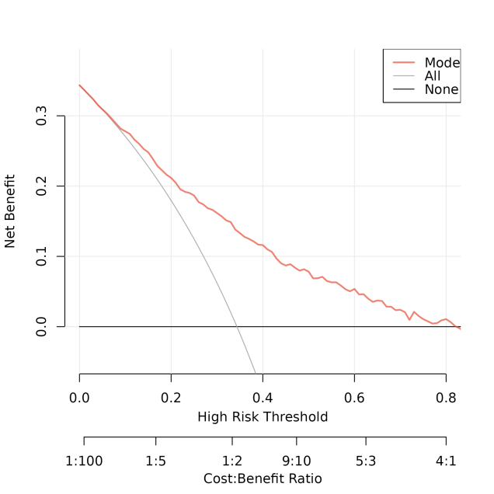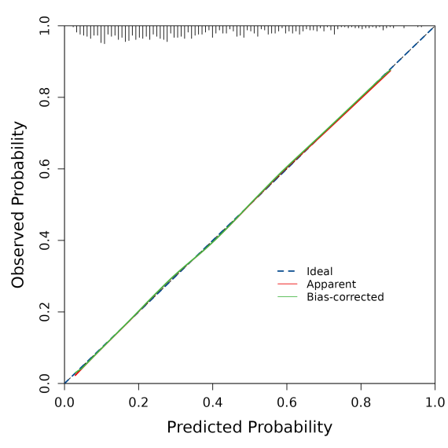
Supplementary Fig. 1. The decision curve analysis and calibration curve of the basic predictive model.

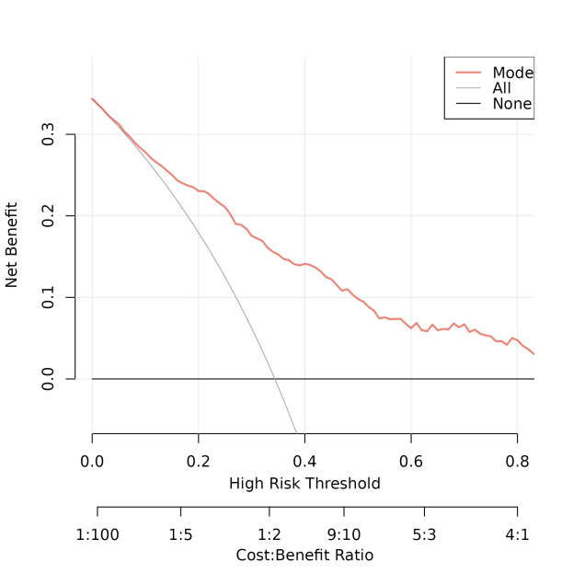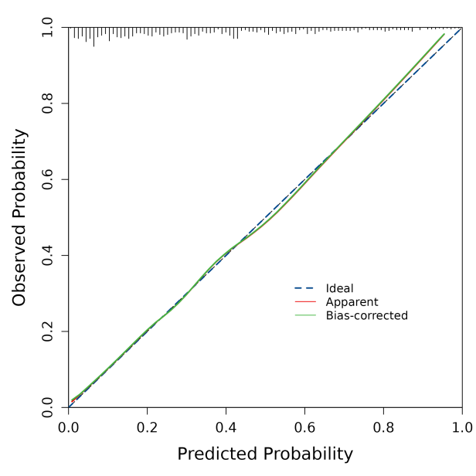
Supplementary Fig. 2. The decision curve analysis and calibration curve of the basic predictive model combined with the TyG-BMI index.

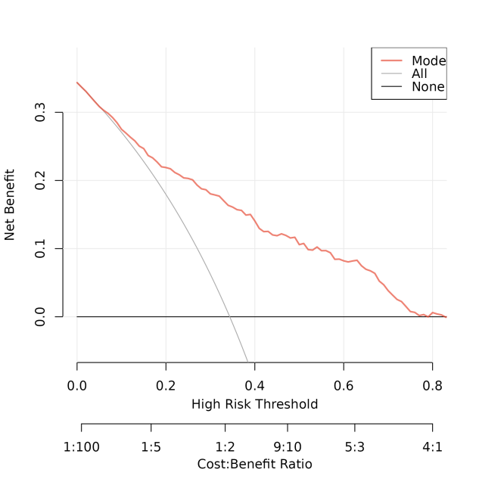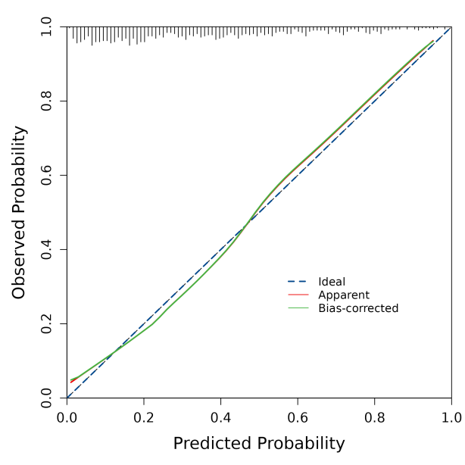
Supplementary Fig. 3. The decision curve analysis and calibration curve of the basic predictive model combined with the TyG index.

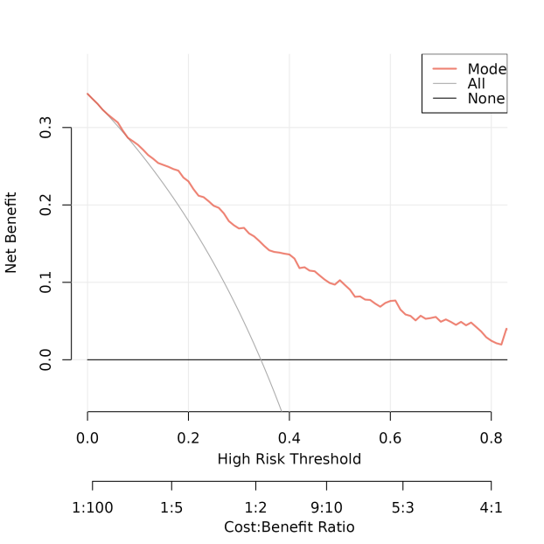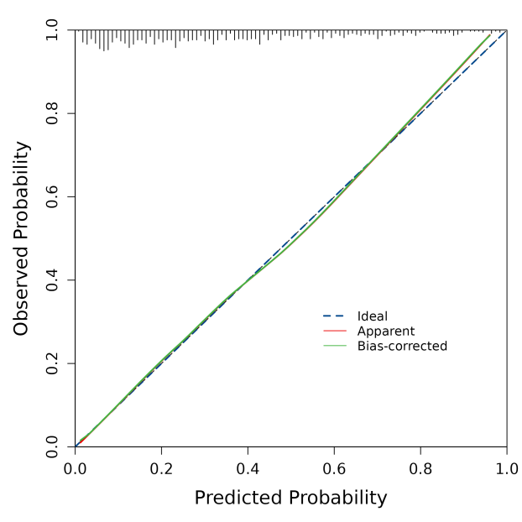
Supplementary Fig. 4. The decision curve analysis and calibration curve of the basic predictive model combined with the BMI.

